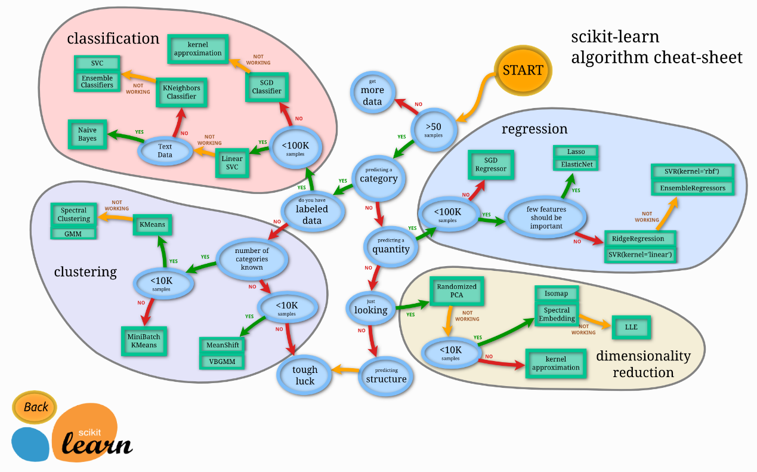

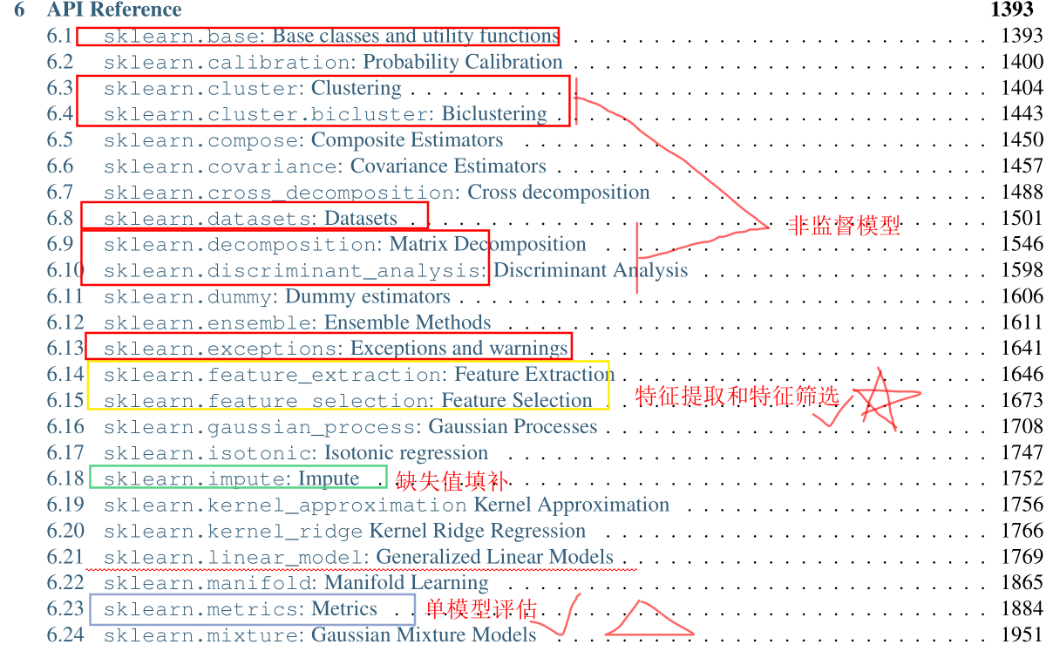

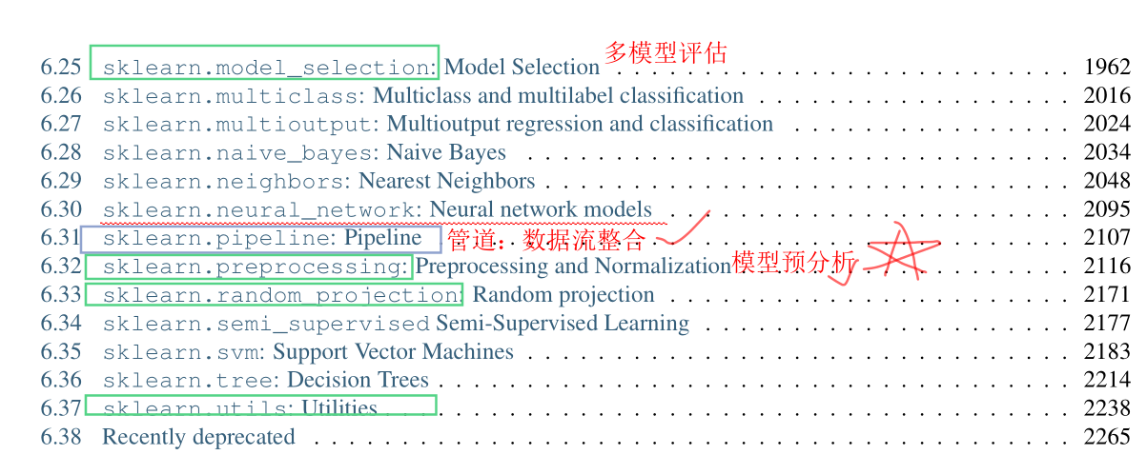



|  |  |
| --- | --- |
| Regression and Linear Models[¶](https://www.statsmodels.org/stable/user-guide.html#regression-and-linear-models)   * [Linear Regression](https://www.statsmodels.org/stable/regression.html) * [Generalized Linear Models](https://www.statsmodels.org/stable/glm.html) * [Generalized Estimating Equations](https://www.statsmodels.org/stable/gee.html) * [Generalized Additive Models (GAM)](https://www.statsmodels.org/stable/gam.html) * [Robust Linear Models](https://www.statsmodels.org/stable/rlm.html) * [Linear Mixed Effects Models](https://www.statsmodels.org/stable/mixed_linear.html) * [Regression with Discrete Dependent Variable](https://www.statsmodels.org/stable/discretemod.html) * [Generalized Linear Mixed Effects Models](https://www.statsmodels.org/stable/mixed_glm.html) * [ANOVA](https://www.statsmodels.org/stable/anova.html) | Time Series Analysis[¶](https://www.statsmodels.org/stable/user-guide.html#time-series-analysis)   * [Time Series analysis **tsa**](https://www.statsmodels.org/stable/tsa.html) * [Time Series Analysis by State Space Methods **statespace**](https://www.statsmodels.org/stable/statespace.html) * [Vector Autoregressions **tsa.vector_ar**](https://www.statsmodels.org/stable/vector_ar.html) |
| Other Models[¶](https://www.statsmodels.org/stable/user-guide.html#other-models)   * [Methods for Survival and Duration Analysis](https://www.statsmodels.org/stable/duration.html) * [Nonparametric Methods **nonparametric**](https://www.statsmodels.org/stable/nonparametric.html) * [Generalized Method of Moments **gmm**](https://www.statsmodels.org/stable/gmm.html) * [Other Models **miscmodels**](https://www.statsmodels.org/stable/miscmodels.html) * [Multivariate Statistics **multivariate**](https://www.statsmodels.org/stable/multivariate.html) | Statistics and Tools[¶](https://www.statsmodels.org/stable/user-guide.html#statistics-and-tools)   * [Statistics **stats**](https://www.statsmodels.org/stable/stats.html) * [Contingency tables](https://www.statsmodels.org/stable/contingency_tables.html) * [Multiple Imputation with Chained Equations](https://www.statsmodels.org/stable/imputation.html) * [Empirical Likelihood **emplike**](https://www.statsmodels.org/stable/emplike.html) * [Distributions](https://www.statsmodels.org/stable/distributions.html) * [Graphics](https://www.statsmodels.org/stable/graphics.html) * [Input-Output **iolib**](https://www.statsmodels.org/stable/iolib.html) * [Tools](https://www.statsmodels.org/stable/tools.html) * [Working with Large Data Sets](https://www.statsmodels.org/stable/large_data.html) * [Optimization](https://www.statsmodels.org/stable/optimization.html) |
|  |  |